

TEMENOS T24

Stream

User Guide

Table of Contents

Dropbox Widget and Code

Introduction 3

Preface 3

Overview 3

Dropbox Saver Button 3

Dropbox Chooser Button 3

Assumptions 3

Getting Started 3

Installation 3

Adding the Dropbox Saver Button 4

Adding the Dropbox Chooser Button 5

# 

# Introduction

## Preface

This User Guide is intended for Developers and provides the step by step instructions for adding Dropbox Saver or Dropdown Chooser custom buttons, in your presentation.

## Overview

### Dropbox Saver Button

The Dropbox Saver button allow users to add files to a drop-box. Users can download files of any size into their drop-box, from a URL, making those files available on all their computers and devices as soon as the download completes. The Saver is a drop-in component that works on web and mobile web.

### Dropbox Chooser Button

The Dropbox Chooser button allow users to download existing files from the Dropbox account into their computers, or to use the URL, without having to worry about authentication or managing uploads and storage.

## Assumptions

It is assumed that you are familiar with the edgeConnect Editors and have working knowledge on edgeConnect.

# Getting Started

## Installation

For manual installation:

1. Copy **com.temenos.widgets.dropbox** folder in your widgets folder (Ex: /{your project/templates }).
2. Restart IDE.

For auto-installation:

1. Run IDE.
2. Make sure ‘Switch Monitor on/off’ is checked.
3. Download or copy the widget **com.temenos.widgets.dropbox.zip** to the monitored folder.

(Navigate to **Tools** - > **Options** -> **Auto-install** and set in **Download Location**, the folder where you copied the widgets.). There is no need to restart IDE.

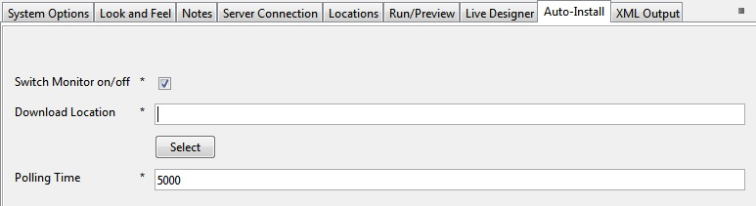

For all Dropbox widgets, you have to set up the settings within **Dropbox Setup** (***App ID*** is common for all Dropbox widgets). See the following image:

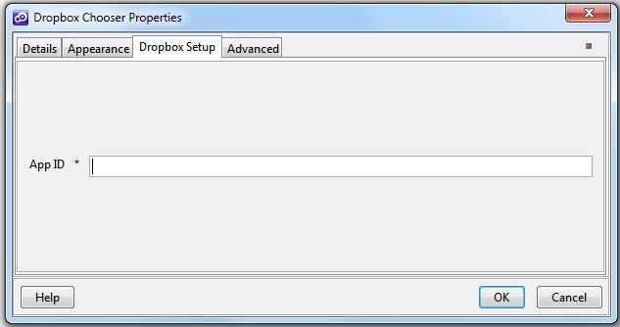

To obtain a valid app ID, you have to create a new application within your Dropbox developer account [**https://www.dropbox.com/developers/apps**](https://www.dropbox.com/developers/apps%20)**.** You can find the Developer Guide here: [**https://www.dropbox.com/developers/reference/devguide**](https://www.dropbox.com/developers/reference/devguide%20) **.**

## Adding the Dropbox Saver Button

To add the dropbox saver button:

1. Insert a new display Item of **Dropbox Saver** type, in the **Presentation Editor**.
2. In the **Dropbox Setup** tab, you have to set up the widget settings.

* **App ID** - the Application ID created on your Dropbox account.
* **File URL** - URL of the file. The Saver should add to the user's Dropbox. The Saver supports HTTP and HTTPS URLs.
* **Alternative File Name** - (optional)user-friendly name of the file that should be saved to the user's Dropbox, can be included if desired. If not included, the filename is inferred from the ‘href’.

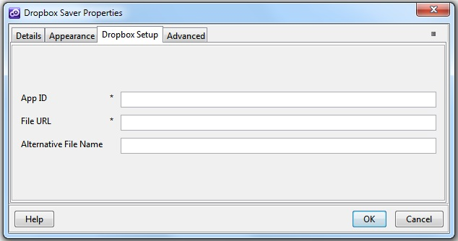

You could find more details on the Dropbox website: [https://www.dropbox.com/developers/dropins/saver](https://www.dropbox.com/developers/dropins/saver%20)

## Adding the Dropbox Chooser Button

To add the dropbox chooser button:

1. You will have to insert a new display Item of **Dropbox Chooser** type, in the **Presentation Editor**.
2. Within **Dropbox Setup** tab, you have to set up the following widget settings:

* **App ID** – the Application ID created on your Dropbox account.



You could find more details on Dropbox website: <https://www.dropbox.com/developers/dropins/chooser/js>